SOMA Program
December 8-11, 2018

Page
4 Schedule at a glance
6 Program
13 Hotel map of meeting rooms

Exhibitors

Some exhibitors will have discounts for conference attendees, or drawings for prizes which
will be announced at lunch Monday (you can come back in the afternoon to see if you won). Some of discounts and prizes are listed with the exhibitors below. Those who placed ads have the page number of the ad listed.

Advertisement
Page:
12 Ability2Access
3 Allied Instructional Services (drawing for CVI kit!)
3 Ambutech Inc. (drawing for two $100 gift certificates!)
18 American Printing House for the Blind
14 Blindfold Games
Braille with Vision at Tampa Lighthouse for the Blind
17 Emerald Coast Vision Aids, Inc.
18 Environmental Access Committee of AER's O&M Division
16 Equal Eyes Vision Services
Feel Good, Inc.
Guiding Eyes for the Blind
17 Guide Dogs for the Blind
17 HumanWare
- Invision Services, Inc.
17 Leader Dogs for the Blind
18 Orientation and Mobility Specialist Organization
The Seeing Eye Inc.
- South Carolina School for the Deaf and the Blind
Second Sight Medical products, Inc.
16 Specialized Education Associates
16 Zimmerman Low Vision Simulation Kit (10% discount to attendees!)

The Florida School for the Deaf and Blind sends us greetings
and wishes for a successful conference --
see their ad on page 15.
SOMA 2018 Conference Committee:
Eileen Bischof and Mickey Damelio, co-chairs
Dona Sauerburger, Program
Mary Phagan-Kean, Registration
-2-
-3-

SOMA Schedule at a Glance
Session descriptions
Presenters

NOTE: MOST SESSIONS ARE REPEATED (but SOME ARE NOT)!
To give you greater choices with fewer conflicts, most sessions are repeated. That means that for each set of concurrent sessions, you’ll be able to choose two out of the 5 presentations offered (the last sessions Tuesday morning are an exception).

How does this work?
The schedule has Concurrent Session Groups A - G. Each Concurrent Session Group has two time slots. One session in each of those time slots is not repeated, so if you want to attend that session, you'll have to do it at that time. The rest of the presentations are repeated, so you can attend them either time. (NOTE: Group G – Tuesday 11:00-12:45 – is an exception to this rule.)

SOMA SCHEDULE:

Saturday, December 8, 2018
9:30-5:00 - Pre-Conference Workshops (included in your registration fee!)

Sunday, December 9, 2018
9:00AM – 7:30 PM Exhibits open
8:15-9:15 General session
9:30-11:00 Concurrent Session Group A (part 1)
11:15-12:00 Exhibitors’ Highlights
12:00-1:30 Lunch (on your own)
1:30-3:00 Concurrent Session Group A (part 2)
3:15-4:15 Concurrent Session Group B (part 1)
4:30-5:30 Concurrent Session Group B (part 2)
5:30-7:30 Exhibitors’ Reception

Monday, December 10, 2018
7:30AM – 5:30PM Exhibits open
8:15-9:45 Concurrent Session Group C (part 1)
9:45-10:15 Break -- Sponsored by
10:15-11:45 Concurrent Session Group C (part 2)
11:45-1:15 Lunch (on your own) – Vendors announce raffles/drawings
1:15-2:15 Concurrent Session Group D (part 1)
2:30-3:30 Concurrent Session Group D (part 2)
3:45-4:30 Concurrent Session Group E (part 1)
4:45-5:30 Concurrent Session Group E (part 2)
5:30-6:30 Blindfold experience

Tuesday, December 11, 2018
8:30-9:30 Concurrent Session Group F (part 1)
9:45-10:45 Concurrent Session Group F (part 2)
11:00-11:45 Concurrent Session Group G (part 1)
12:00-12:45 Concurrent Session Group G (part 2)
-4-
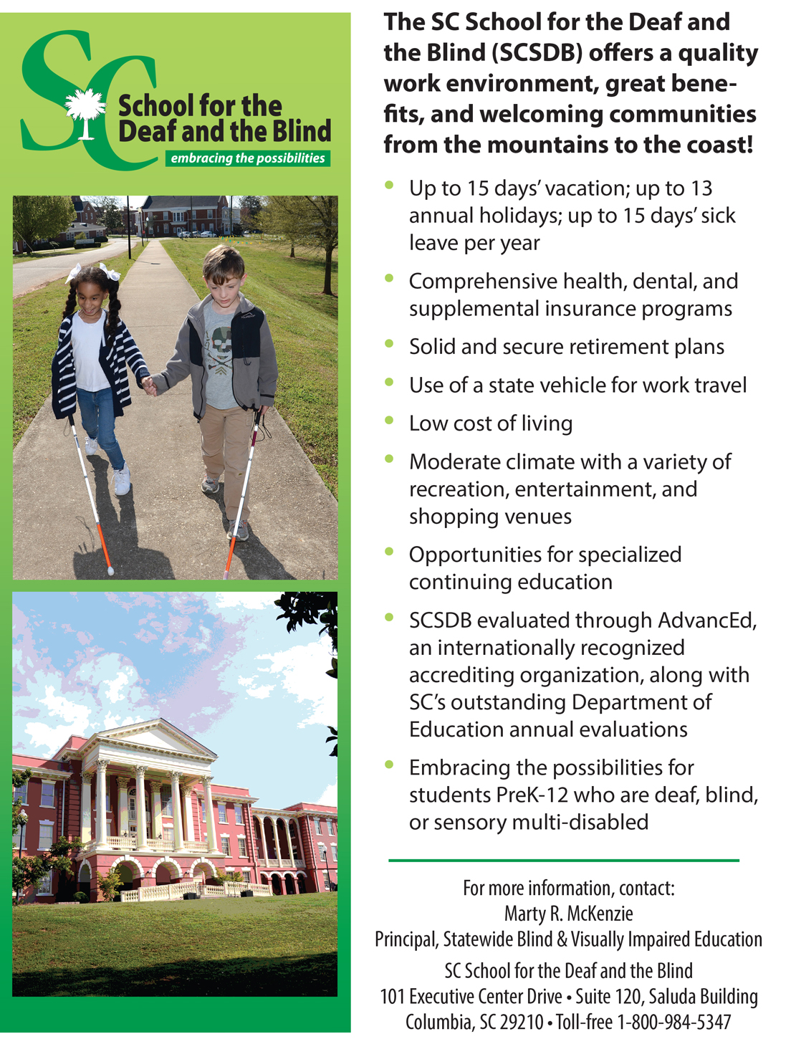

-5-
SOMA PROGRAM

Saturday, December 8, 2018:

Pre-Conference Workshops (included in your registration fee!)

TRACK 1 – ROOM: Bayshore Ballroom 1,2,3: (popcorn break at 3:15)
- 9:30-12:30; 2:00-5:00: Orientation and Mobility for Children with Multiple Impairments -- Mickey Damelio

TRACK 2 – ROOM: Bayshore Ballroom 4,5,6: (popcorn break at 3:15)
- 9:30-12:30: You live where?!?! Ideas for maximizing O&M Services to reach remote areas or stretch your resources: Research and Practice - Amy Parker and Mary Tellefson
HANDOUTS

- 2:00-5:00: Motivation Mastery: Applying principles of game design to motivate your students or staff to achieve their best - Stephan Sauerburger

Sunday, December 9, 2018
9:00 AM - 7:30 PM - Exhibits open
8:15-9:15 General session – ROOM: Gasparilla Ballroom 1,2,3

Have you heard about the exciting new Orientation and Mobility Specialist Association? Eileen Siffermann, Edward Bell, Mickey Damelio, Eileen Bischof, Susan Langendonk, Lukas Franck

9:30-11:00 Concurrent Session Group A (Part 1)

Will it be repeated at 1:30? | Room | Title | Presenters
YES | Bayshore 1,2 | Beyond Your Expertise: What’s Your Superpower? HANDOUTS | JoAnne Chalom
YES | Bayshore 3,4 | O&M Career, College and Community Readiness Standards HANDOUTS | Mary Tellefson and Kathryn Botsford
YES | Bayshore 5,6 | Wheelchair Mobility for Guide Dog Users | Lee Stanway
NOT  repeated! | Gasparilla 1,2 | Transitioning from Teaching Basic Echolocation to Advanced Echoidentification | Dr. Dawn Anderson and Sarahelizabeth Baguhn

11:00-11:15 Break with snacks in Exhibit area

11:15-12:00 General session – ROOM: Gasparilla Ballroom 1,2,3

Exhibitors' Highlights (ACVREP credit provided)
SUNDAY, December 9, 2018 (continued)
12:00-1:30 Lunch (on your own)
1:30-3:00 Concurrent Session Group A (Part 2)

Was it presented at 9:30? | Room | title | Presenters
Yes | Bayshore 1,2 | Beyond Your Expertise: What’s Your Superpower? HANDOUTS | JoAnne Chalom  handouts
Yes | Bayshore 3,4 | O&M Career, College and Community Readiness Standards HANDOUTS | Mary Tellefson and Kathryn Botsford
Yes | Bayshore 5,6 | Wheelchair Mobility for Guide Dog Users | Lee Stanway
NOT  repeated! | Gasparilla 1,2 | Shared streets and sidewalks: Accessibility considerations and recommendations | Janet Barlow

3:00-3:15 Break with snacks in Exhibit area

3:15-4:15 Concurrent Session Group B (Part 1)

Will it be repeated at 4:30? | Room | Title | Presenters
YES | Bayshore 1,2 | Designing Fun and Purposeful O&M Lessons Using the Geocaching App | Lacey Long
YES | Bayshore 3,4 | Off-Road O&M | Jay Hardwig
YES | Bayshore 5,6 | Partial occlusion tool: aiding in simultaneous instruction of low vision and sensory skills | Imani William
NOT  repeated! | Gasparilla 1,2 | O&M Immersion Program with The Guide Dogs for the Blind HANDOUTS | Marc Gillard

4:30-5:30 Concurrent Session Group B (Part 2)

Was it presented at 3:15? | Room | Title | Presenters
YES | Bayshore 1,3 | Designing Fun and Purposeful O&M Lessons Using the Geocaching App | Lacey Long
YES | Bayshore 3,4 | Off-Road O&M | Jay Hardwig
YES | Bayshore 5,6 | Partial occlusion tool: aiding in simultaneous instruction of low vision and sensory skills | Imani William
NOT  repeated! | Gasparilla 1,2 | New techniques and strategies in Orientation and Mobility | Janet Barlow

5:30-7:30 EXHIBITORS' RECEPTION – in Exhibit area

-7-
Monday, December 10, 2018

7:30 AM - 5:30 PM - Exhibits open
8:15-9:45 Concurrent Session Group C (Part 1)

Will it be repeated at 10:15? | Room | title | Presenters
Yes | Bayshore 1,2 | Using Simulation Software to Teach Students How to Deal with Uncontrolled Crossings | Laura Zierer and  Dona Sauerburger
Yes | Bayshore 3,4 | AER Accreditation Council (AERAC) and the Accreditation Program HANDOUTS | Eileen Siffermann and Dr. Bill Wiener
Yes | Bayshore 5,6 | TBA
NOT  repeated! | Gasparilla 1,2 | Research Validation of the Birth to 6 O&M Skills Inventory (B6OMSI) | Sarahelizabeth Baguhn and  Dr. Dawn Anderson

9:45-10:15
BREAK in Exhibit area

Sponsored by Invision Services, Inc.
THANK YOU!

10:15-11:45 Concurrent Session Group C (Part 2)

Was it presented at 8:15? | Room | Title | Presenters
Yes | Bayshore 1,2 | Using Simulation Software to Teach Students How to Deal with Uncontrolled Crossings | Laura Zierer and  Dona Sauerburger
Yes | Bayshore 3,4 | AER Accreditation Council (AERAC) and the Accreditation Program HANDOUTS | Eileen Siffermann and Dr. Bill Wiener
Yes | Bayshore 5,6 | TBA
NOT  repeated! | Gasparilla 1,2 | Climbing to Success | Sue Glaser

-8-
Monday, December 10, 2018 (continued)

11:45-1:15 Lunch (on your own)

Raffle winners will be announced in the Exhibit area! Pick up prizes before 5:30.

1:15-2:15 Concurrent Session Group D (Part 1)

Will it be repeated at 2:30? | Room | Title | Presenters
Yes | Bayshore 1,2 | Barriers and Facilitators to ECC Instruction Reported by O&M Specialists | Nicholas Trotter and Susan Yarbrough
Yes | Bayshore 3,4 | Little Locomotives - Ten years later | Alicia Pugh and Jennifer Jeffcoat
Yes | Bayshore 5,6 | The FUNdamentals of Teaching Students with Deafblindness | Tara Brown-Ogilvie
NOT  repeated! | Gasparilla 1,2 | An Alternative Model in Orientation & Mobility | Erica Ihrke

2:30-3:30 Concurrent Session Group D (part 2) P

Was it presented at 1:15? | Room | Title | Presenters
Yes | Bayshore 1,2 | Barriers and Facilitators to ECC Instruction Reported by O&M Specialists | Nicholas Trotter and Susan Yarbrough
Yes | Bayshore 3,4 | Little Locomotives - Ten years later | Alicia Pugh and Jennifer Jeffcoat
Yes | Bayshore 5,6 | The FUNdamentals of Teaching Students with Deafblindness | Tara Brown-Ogilvie
NOT  repeated! | Gasparilla 1,2 | Reinventing the Goalball | Sue Glaser and Andrea Wallace

-9-
Monday, December 10, 2018 (continued)

3:45-4:30 Concurrent Session Group E (Part 1)

Will it be repeated at 4:45? | Room | Title | Presenters
Yes | Bayshore 1,2 | Orientation through Technology HANDOUTS | Sara Leal and  Judy Porro
Yes | Bayshore 3,4 | Launching the Ship: Early Orientation and Mobility and Parent Centered Education | Lisa Lind,  Pam Arbeiter,  Ann Cummins,  Shelley Donahue, and Sara Bushland
Yes | Bayshore 5,6 | "Tapping" into Success | Danita Snulligan
NOT  repeated! | Gasparilla 1,2 | Teaching techniques to increase drivers’ yielding to a student in a school setting | Matthew Stewart

4:30-4:45 Break with snacks in Exhibit area

4:45-5:30 Concurrent Session Group E (Part 2)

Was it presented at 3:45? | Room | Title | Presenters
Yes | Bayshore 1,2 | Orientation through Technology HANDOUTS | Sara Leal and  Judy Porro
Yes | Bayshore 3,4 | Launching the Ship: Early Orientation and Mobility and Parent Centered Education | Lisa Lind,  Pam Arbeiter,  Ann Cummins,  Shelley Donahue, and Sara Bushland
Yes | Bayshore 5,6 | "Tapping" into Success | Danita Snulligan
NOT  repeated! | Gasparilla 1,2 | - Training Guide Dog Teams to go on Exercise Runs and the Benefits of Empowering Consumers to Exercise More | Ben Cawley

5:30-6:30 - BLINDFOLD EXPERIENCE - Sam Picciano and Dona Sauerburger
(ACVREP credit provided)

Meeting rooms - Gasparilla 4 and Exhibit area

-10-
Tuesday, December 11 2018

8:30-9:30 Concurrent Session Group F (Part 1)

Will it be repeated at 9:45? | Room | Title | Presenters
Yes | Bayshore 1,2 | - Literacy & Mobility: Engaging Learners by Pairing Orientation and Mobility Skills with Braille/Print Readiness Activities HANDOUTS | Lindsey Moore
Yes | Bayshore 5,6 | - Changing your world, one step at a time: Practices for making a difference HANDOUTS | Stephan Sauerburger and Dona Sauerburger
NOT  repeated! | Gasparilla 1,2 | Technology for Training Apprentice Guide Dog Mobility Instructors HANDOUTS | Amy Gunn and Kelly Chadwick

9:45-10:45 Concurrent Session Group F (Part 2)

Was it presented at 8:30? | Room | Title | Presenters
Yes | Bayshore 1,2 | - Literacy & Mobility: Engaging Learners by Pairing Orientation and Mobility Skills with Braille/Print Readiness Activities HANDOUTS | Lindsey Moore
Yes | Bayshore 5,6 | - Changing your world, one step at a time: Practices for making a difference HANDOUTS | Stephan Sauerburger and Dona Sauerburger
NOT  repeated! | Gasparilla 1,2 | - Guide Dog Mobility Instructor panel | Lukas Franck

10:45-11:00 Break with snacks in Exhibit area

11:00-11:45 Concurrent Session Group G (Part 1)

Will it be repeated at 12:00? | Room | Title | Presenters
Yes | Bayshore 1,2 | - Development of Tactile Encodings for Interior Maps | Howard Kaplan
NOT  repeated! | Bayshore 3,4 | - Interactive web-based Apprentice Education: Heads in the Clouds | Rod Haneline
NOT  repeated! | Gasparilla 1,2 | - Are We All on the Same Page? Using Traffic Sound for Alignment | Lukas Franck and Mickey Damelio

-11-

Tuesday, December 11, 2018 (continued)

12:00-12:45 Concurrent Session Group G (Part 2)

Was it presented at 11:00? | Room | Title | Presenters
Yes | Bayshore 1,2 | - Development of Tactile Encodings for Interior Maps | Howard Kaplan
NOT  repeated! | Bayshore 3,4 | - Who Doesn’t Love Resources?  - HANDOUTS | Joy Bieder
NOT  repeated! | Gasparilla 1,2 | - A year working with patients with artificial vision through retinal prosthesis | Mickey Damelio

-12-
Hotel Map of Meeting Rooms

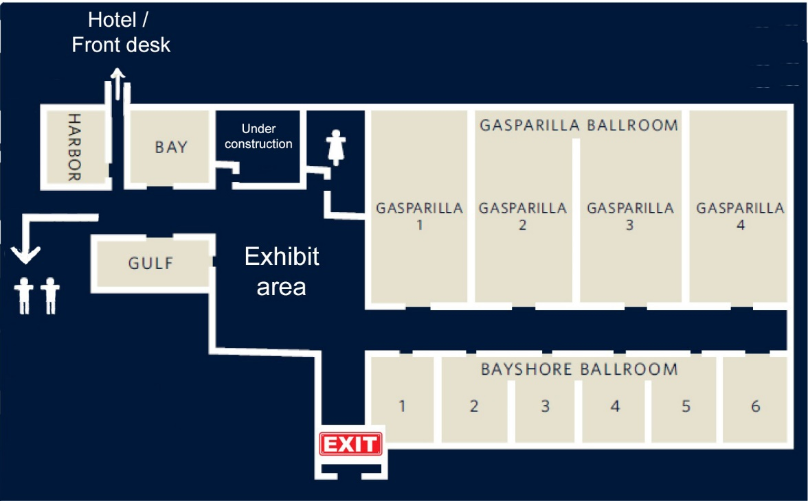

Description: The Exhibit area is rectangle, with the bathrooms along the wall at the top of our map. The women’s room is on the right, the men’s room is on the left (it is closed for construction but there are two men’s rooms available as described below).

When we stand at the back of the Exhibit area and face the bathrooms, the right wall has a hall extending to our right. If we turn right and walk along that hall from the exhibits, we pass on our left the Gasparilla Ballroom, with doors to Gasparilla 1, 2, 3 and then 4. On our right (starting from the exhibit area) we’ll pass the Bayshore Ballroom, with doors to Bayshore 1, 2, 3, 4, 5 and then 6.

If we go back to the Exhibit area and stand close to the bathrooms (facing them), the left wall has another hallway extending to our left. If you turn left and walk along that hall from the exhibits, you pass on your left the Gulf Room, and on your right you pass the Bay room, and then another hallway.

If you continue straight, you’ll find a hall on your left where the men’s bathrooms are. If you turn right after passing the Bay room and walk into that hallway, you pass the door into the Harbor room on your left. If you continue walking, you pass the elevators on your left, and then you enter the hotel’s lobby with the front desk and restaurant/bar.

From the Exhibit area, there is another hallway, starting on the wall that is across from the bathrooms (at the bottom of our map, next to the hall to the ballrooms). That hall goes to an exit leading to one of the parking lots.

-13-
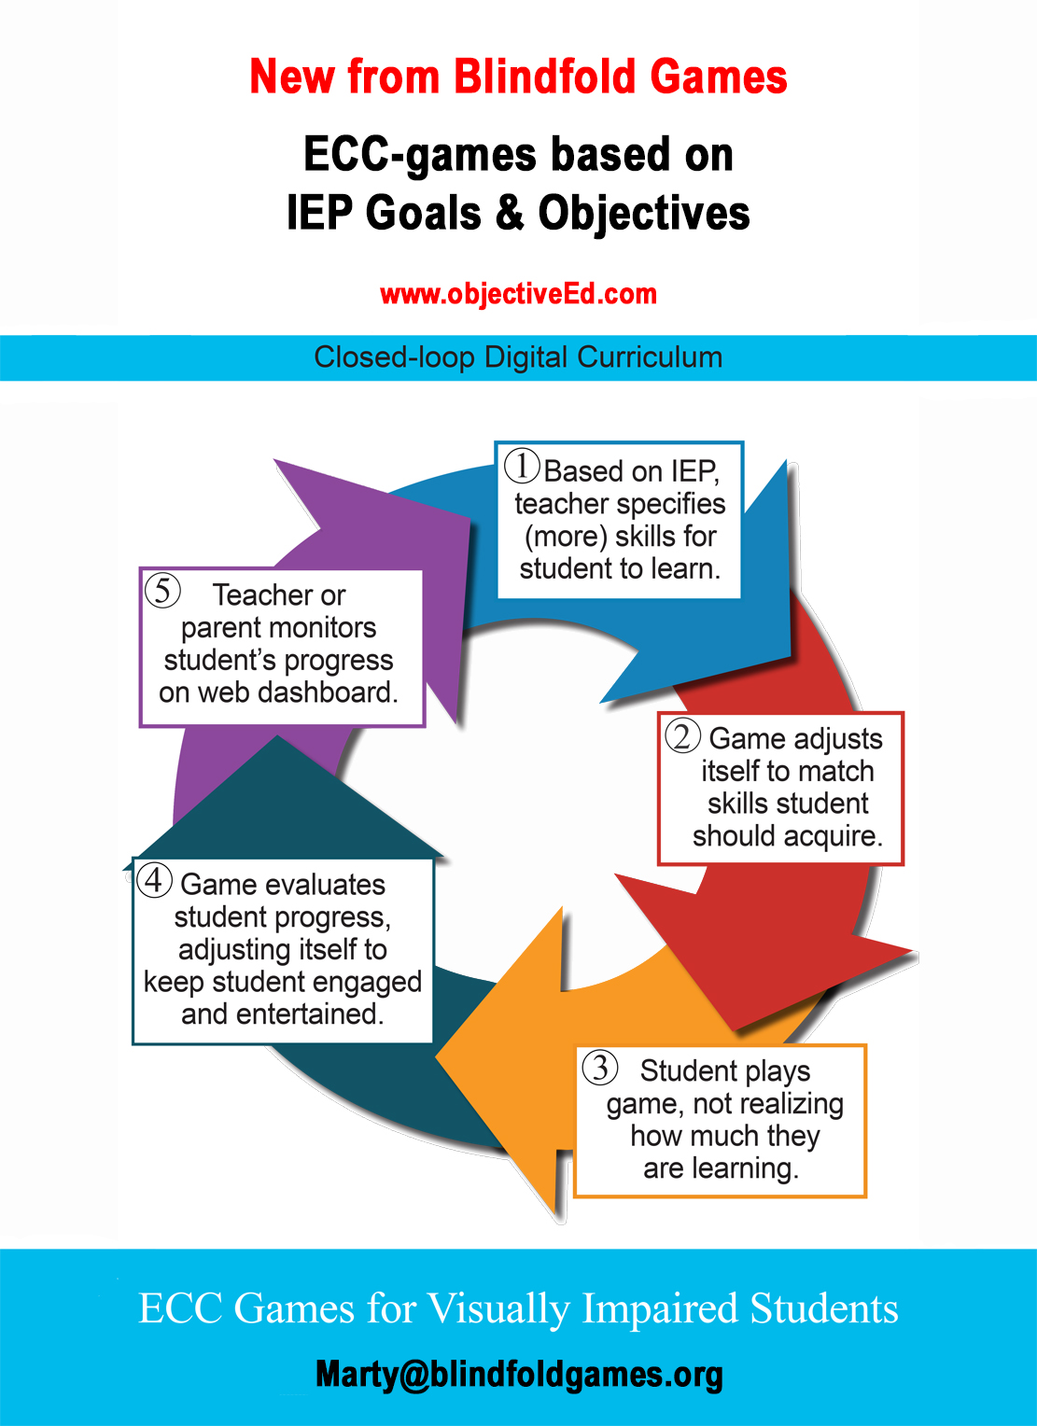
-14-
-15-
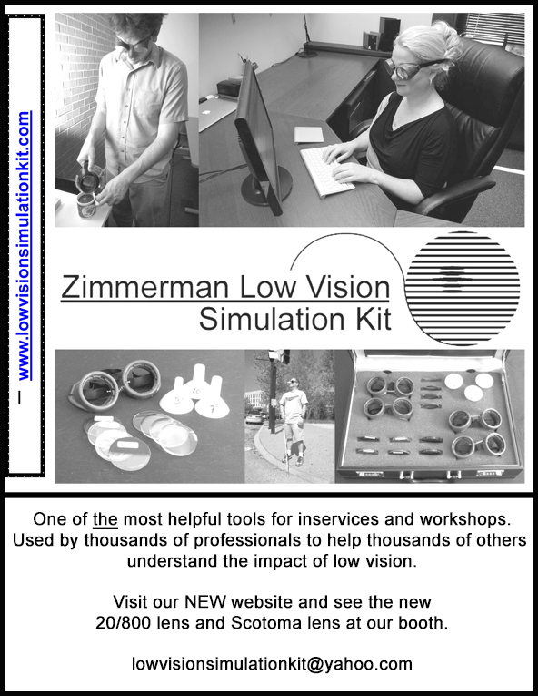
-16-

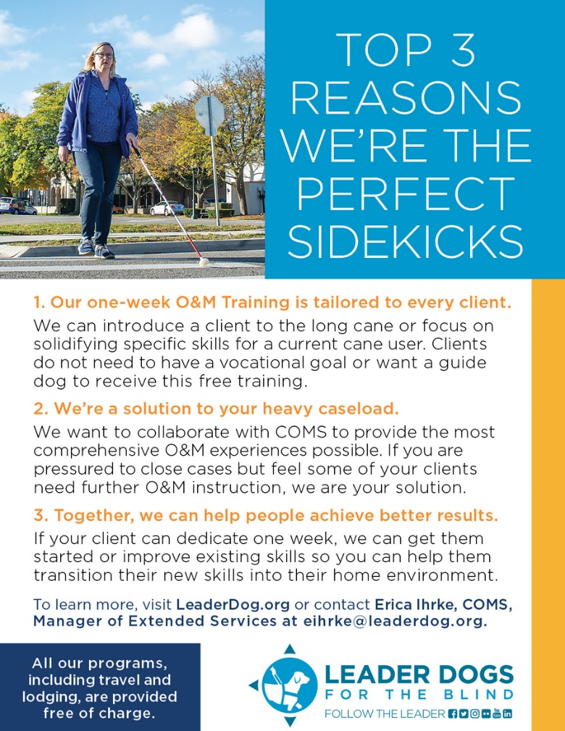
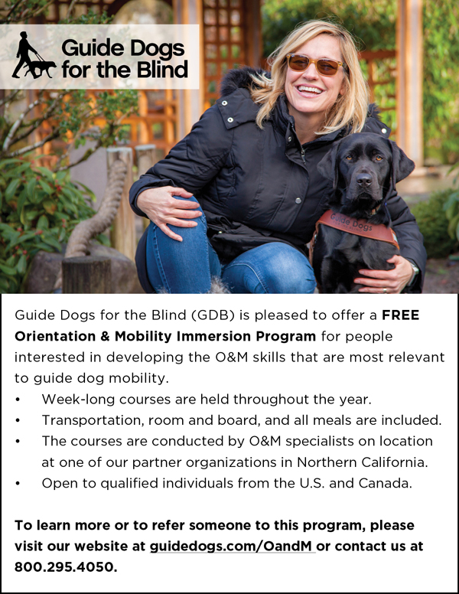

-17-
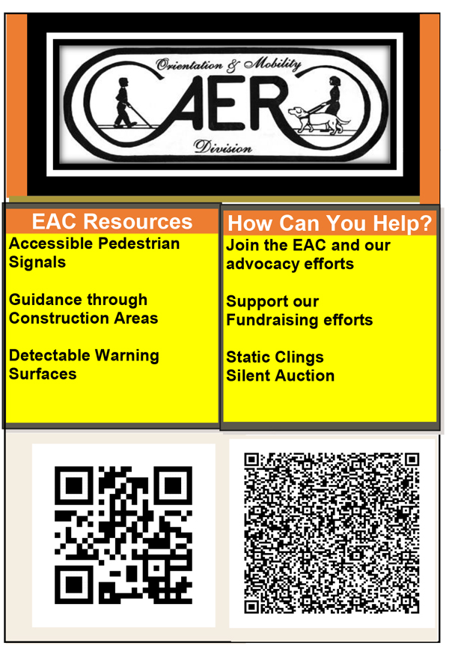

www.usomsa.org

We welcome you to come to our table in the Exhibit area and to the general session Sunday morning -- learn about this exciting organization and become involved!

-18-

